Eat Fresh Organic Vegetables Each Week for 20 weeks. Buy Local and Support a Local Farm.
Make vegetable consumption easier with a weekly distribution of vegetables from The Herb Hill Farm , now in Pepperell, MA. The Herb Hill Farm is offering weekly pick-up of vegetables reducing your carbon footprint, saving you time and hassle; while providing great-tasting, nutritious organic produce. Sign up for a farmshare with us this season and have your weekly box/bag of local produce delivered to 439 Lowell St, Andover or pick-up directly at the farm at 16 B Brookline St. Pepperell, just south of Nashua NH. Pick-up day and times will be determined closer to the season. For more about the farm see: www.theherbhillmicrodairy.mckain.me
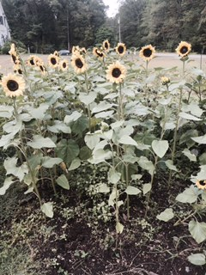
How does a CSA farmshare work?
By purchasing a share you help us cover our initial costs of growing the food. Then each week starting in late May, you receive a weekly distribution of fresh, certified-organic vegetables in return. In a CSA, you share in some of the risks of farming such as the weather, but you receive immediate direct access to the freshest and most nutritious produce each week. We partner with Red Fire Farm in Granby, MA, to grow a diverse mix of organic greens, vegetables, and common cooking herbs. We plan to purchase vegetables that we do not grow to include in your weekly distribution providing a bountiful array of produce. Our farms are both certified organic growers. This means we grow by increasing the biodiversity of organisms in the soil, adding organic-approved improvements only. We work with nature valuing our natural eco-systems, thus improving our environment.
Medium Sample Box
1 bunch scallions
1 lb bag gourmet salad mix
3-4 cucumbers
1 bunch (3) red/gold beets
1 bunch green curly kale
3 large tomatoes

Our 2017 Programs: We have 2 sizes to offer:
Small | Medium
$360 ($10 admin fee) | $510 ($10 admin fee)
Consists of 4 different items  each week with multiples  of some items | Consists of 6 different items  each week with multiples  of some items
Value of cost per pound = $4.16 | Value of cost per pound =$4.16
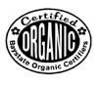
Organic certification is your guarantee that no pesticides, herbicides, or
chemical fertilizers, have been used to grow your food.

Please select the size and location you prefer:
Small or Medium Size Vegetable share: Pickup in Andover or Pepperell
Times TBD

Name_______________________________________Telephone ________________________________
Email________________________________________________________________________________
I understand that The Herb Hill and Red Fire Farms are local farms supported by their CSA programs, and I agree to share with the farmers the risks and rewards inherent in growing food.

Signature_________________________________________Date_______________________________

